Available online at [www.sciencedirect.com](http://www.sciencedirect.com/)



AASRI Procedia 3 (2012) 661 – 666

2012 AASRI Conference on Modeling, Identification and Control

Computer Generation of 3D Textile Draping Simulation

Yan Jianga, Minghai Cuib, Jing Huc *

*a Computer Information Center, Beijing Institute of Fashion Technology, Beijing 100029 P. R. China*

*bSchool of Fashion Art and Engineering, Beijing Institute of Fashion Technology, Beijing 100029 P. R. China*

*cDepartment of Fine Arts, Artistic Vocational College of Anhui, Hefei 230000 P. R. China*

**Abstract**

In order to simulate the deformation of different fabrics, A method was proposed to realize textile draping simulation of complex cloth materials. A BP neural network was constructed to acquire the nonlinear relationship between fabric mechanical parameters and control parameters of the 3D textile simulation system. Simulation experiment had been carried out on fifteen kinds of familiar fabrics, and the results showed that this method can realize the simulation better with material information. The virtual clothing based on the method is more specific and will be propitious to improve the reality of the whole simulation system.

© 2012 The Authors. Published by Elsevier B.V.

© 2012 Published by Elsevier B.V. Selection and/or peer revi[ew under responsi](http://creativecommons.org/licenses/by-nc-nd/3.0/)bility of American Applied Science Research Institute

Open access under [CC BY-NC-ND license.](http://creativecommons.org/licenses/by-nc-nd/3.0/)

Selection and/or peer review under responsibility of American Applied Science Research Institute

*Keywords:* Draping simulation, Mechanical performance, Neural network

# Introduction

Under the action of gravity, the fabrics will droop naturally and form curved surfaces, namely draping property. It is one of the most important factors for the aesthetic appearance of the fabric. In the 1980s ,the computer graphics scholars began to simulate the textile draping. The earliest and landmark literature in this field was accomplished by Weil[1].He implemented the simulation by the geometry method. At the same time, Feynman[2] did the fabric draping simulation by the physical way for the first time in his MIT master's thesis. Currently, the 3D fabric simulation is not only used in multi-media world, but also as a tool for display and

* Corresponding author. Tel.: 086-010-64288182.

*E-mail address:* [jsjjy@bift.edu.cn.](mailto:jsjjy@bift.edu.cn)

2212-6716 © 2012 The Authors. Published by Elsevier B.V. Open access under [CC BY-NC-ND license.](http://creativecommons.org/licenses/by-nc-nd/3.0/) Selection and/or peer review under responsibility of American Applied Science Research Institute doi:10.1016/j.aasri.2012.11.105

design used in modern garment industry gradually[3,4]. For example, custom clothing, virtual try-on on web etc. have made full use of this technology.

When virtual clothing appears in the games or films, people usually just pay attention to the visual effect of the clothing , but do not care of the material of the clothing. However, when the simulation is used in the field of garment CAD, the mechanical properties of the fabric is crucial. In the paper, we completed the static drape simulation of 15 samples , and then applied these simulation parameters to clothing, and ultimately achieved the virtual clothing of specific styles.

In the past 20 years, the textile engineering and computer graphics researchers implemented the 3D textile simulation jointly. They proposed and achieved many simulation methods based on different models. At 1994's SIGGRAPH, Breen[5] gave a group of the comparing. The one was the real pictures of textiles draping on the table ,and the other was the simulation effect of this scene generated by computer. At the first time, researchers observed the physical properties of different fabrics would bring different simulation effects. The Browzwear company had developed the FKT (Fabric Testing Kit), i.e. special fabric mechanical properties testing system, in its clothing simulation system V-Stitcher. The test results of FKT could be directly used as the simulation parameters of V-Stitcher, and then the virtual garment included fabric material information. Zhong Yueqi[6] used silk, wool, polyester fabric as samples to achieve piecewise polynomial approximation of the bending and shear spring simulation coefficient.

The innovation of this paper was the method of obtaining the simulation parameters. Neural Network was considered the first time to be used in the 3D textile draping simulation, and realized the nonlinear mapping between the the fabric mechanical performance and the control parameters of simulation model. The following chapter would focus on the design and implementation.

# System Design and Implementation

* 1. *System Structure Model*

The system structure model was divided into a physical layer, a basic layer, a prediction layer and application layer, as shown in Fig 1.

The physical layer was the real fabric sample library. Attention should be paid in selecting samples to get a more reasonable distribution. Usually rich sample library made the final effect more ideal.

The basic layer was composed of three parts, namely mechanical parameters test module, draping characteristics test module and fabric deformation simulation module. First of all, we used Kawabata Evaluation System(KES) to test the mechanical properties of fabric samples, and every sample would be described by 16 mechanical values. According to the conclusions of Zuo Tonglin[7], 8 parameters, e.g. the fabric drape coefficient, the number of wave crest, draping radius etc., made up of the matrix for describing the performance. Through the correlation analysis for two data sets above-mentioned, we selected Tensile Work WT, Tensile Ration RT, etc. 7 important mechanical parameters to characterize the draping performance of fabric, namely neural network input data set A. The output data set B of neural network came from the self-development textile simulation system based on PhysX SDK.

Prediction layer established the BP neural network according the data sets A and B provided by the base layer, and then the mapping relationship between the data sets A and B was gotten. This layer would combine mechanics parameter test, draping characteristics testing and computer simulation.

In the application layer, some kind of real fabrics would be simulated by computer. According to the basic data set A and the nonlinear mapping relationship between A and B, we got the control parameter data set B. The corresponding deformation of this fabric would be simulated by the data set B in the basic layer’s 3D

textile simulation system. Eventually, the purpose of simulating the different types of fabrics was achieved by the system.

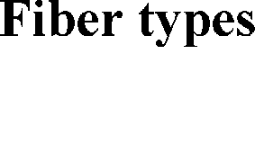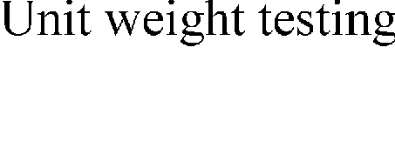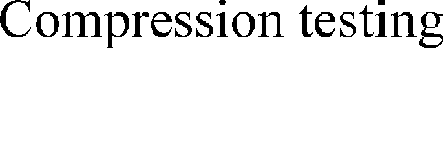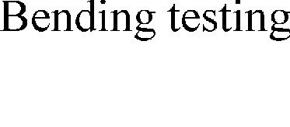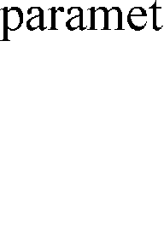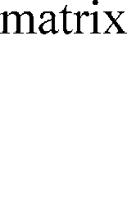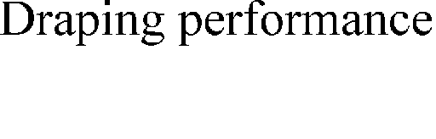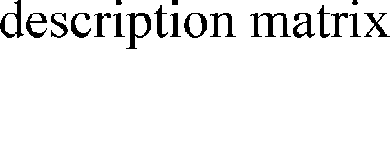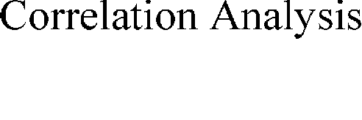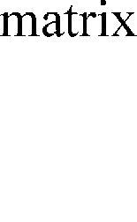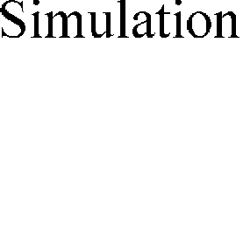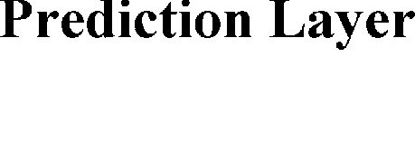

Fig.1. Simulation system structure model based on fabric mechanical properties

* 1. *Build Neural Networks*

In order to build the predictive neural network, we must consider the number of hidden layers and the specific number of nodes firstly. According to the work of Lippmann[8] and Kolmogorov theorem[9], a three- layer BP neural network structure was established. The number of network input was 7, as follows: tensile work WT, tensile ration RT, bending stiffness B, bending hysteresis 2HB, thickness T0, average coefficient of friction MIU, weight per square meter W. The output number was 6, namely: longitude mesh size U, latitudinal mesh size V, thickness T, bending restraint coefficient B, stretch restraint coefficient S and damping coefficient D. At this time, the system established a structure of 7-15-6 BP neural network.

* 1. *The Realization of Neural Network*

The system selected 13 kinds of fabric as the training sample, and set 6# and 9# as the test sample. In the BP network, the transfer function of the hidden layer was the hyperbolic tangent of the S-shaped, and the transfer function of the output layer was the linear transfer function . In order to eliminate the impact of training results because of the different units of input data, the way of normalization was used.

Network was driven by the gradient descent method, i.e., the traingdm function was the network training function. After 1333 steps of training, the network error had reached the target accuracy, and the network

training was successful. The output values of the network at this time was shown in Table 1. Using the successful network to predict the fabric sample 6# and 9#, the result was that the squared error Ep of the samples satisfied the system requirements

Table 1. Neural network hidden layer output value after training

NO. Actual output value *yk*

Desired output value *yk*

_

Error *Ep*

|  |  |  |  |  |  |  |  |  |  |  |  |  |  |
| --- | --- | --- | --- | --- | --- | --- | --- | --- | --- | --- | --- | --- | --- |
|  | U | V | T | B | S | D | U | V | T | B | S | D |  |
| 1# | 0.4965 | 0.2998 | 0.2011 | 0.9472 | 0.4854 | 0.0931 | 0.50 | 0.30 | 0.20 | 0.95 | 0.50 | 0.10 | 0.000047 |
| 2# | 0.3145 | 0.3028 | 0.1891 | 0.7248 | 0.5385 | 0.2423 | 0.30 | 0.30 | 0.20 | 0.70 | 0.50 | 0.20 | 0.000704 |
| 3# | 0.3029 | 0.3981 | 0.2022 | 0.9843 | 0.7648 | 0.0837 | 0.30 | 0.40 | 0.20 | 1.00 | 0.80 | 0.10 | 0.000295 |
| 4# | 0.3049 | 0.3757 | 0.1621 | 0.5302 | 0.5668 | 0.5203 | 0.30 | 0.40 | 0.15 | 0.5 | 0.60 | 0.50 | 0.000531 |
| 5# | 0.4959 | 0.5029 | 0.2487 | 0.8012 | 0.7243 | 0.1121 | 0.50 | 0.50 | 0.25 | 0.8 | 0.70 | 0.10 | 0.000128 |
| 7# | 0.1981 | 0.3588 | 0.1948 | 0.8647 | 0.4851 | 0.4691 | 0.20 | 0.35 | 0.20 | 0.9 | 0.50 | 0.50 | 0.000422 |
| 8# | 0.2869 | 0.3137 | 0.149 | 0.4816 | 0.5215 | 0.4671 | 0.30 | 0.30 | 0.15 | 0.5 | 0.50 | 0.50 | 0.000374 |
| 10# | 0.3018 | 0.3981 | 0.3488 | 0.6996 | 0.3937 | 0.049 | 0.30 | 0.40 | 0.35 | 0.7 | 0.40 | 0.05 | 0.000008 |
| 11# | 0.3974 | 0.4498 | 0.204 | 0.8563 | 0.509 | 0.1042 | 0.40 | 0.45 | 0.20 | 0.85 | 0.50 | 0.10 | 0.000027 |
| 12# | 0.4984 | 0.4016 | 0.3507 | 0.8529 | 0.5022 | 0.0979 | 0.50 | 0.40 | 0.35 | 0.85 | 0.50 | 0.10 | 0.000004 |
| 13# | 0.4985 | 0.2999 | 0.1985 | 0.9961 | 0.4984 | 0.4977 | 0.50 | 0.30 | 0.20 | 1.00 | 0.50 | 0.50 | 0.000005 |
| 14# | 0.351 | 0.3497 | 0.1522 | 0.9639 | 0.2142 | 0.1134 | 0.35 | 0.35 | 0.15 | 0.95 | 0.20 | 0.10 | 0.000097 |
| 15# | 0.302 | 0.2986 | 0.2008 | 1.0022 | 0.1998 | 0.1004 | 0.30 | 0.30 | 0.20 | 1.00 | 0.20 | 0.10 | 0.000002 |
| 6#* | 0.2723 | 0.3820 | 0.2373 | 0.7912 | 0.3568 | 0.2507 | 0.30 | 0.35 | 0.20 | 0.8 | 0.50 | 0.30 | 0.004366 |
| 9#* | 0.4765 | 0.4527 | 0.2538 | 0.8836 | 0.5245 | 0.0059 | 0.45 | 0.45 | 0.30 | 0.85 | 0.50 | 0.05 | 0.001086 |

*Testing sample

# Experimental Results and Analysis

According to the system structure model, on the basis of the Windows operating system and OpenGL, we completed the virtual clothing display system. Here are the experimental results and analysis.

Table 2. Comparison of actual fabric drape with the simulated results

1#(η=0.94) 2#(η=0.97) 3#(η=0.96) 4#(η=0.93) 5#(η=0.95)

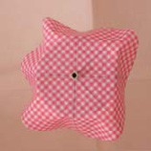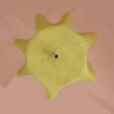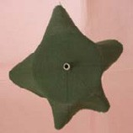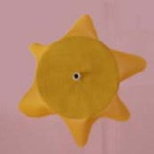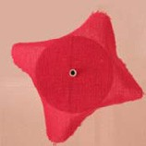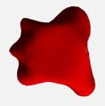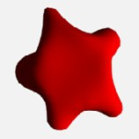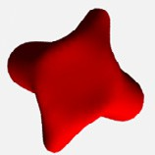

real effect

simulated

result

6#(η=0.89) 7#(η=0.97) 8#(η=0.91) 9#(η=0.93) 10#(η=0.96)

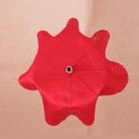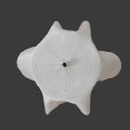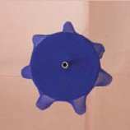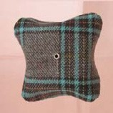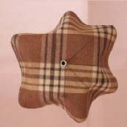

real effect

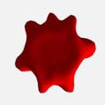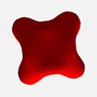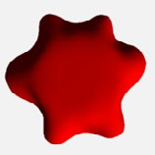

simulated result

11#(η=0.98) 12#(η=0.96) 13#(η=0.94) 14#(η=0.93) 15#(η=0.89)

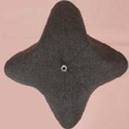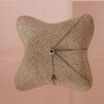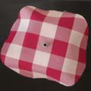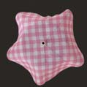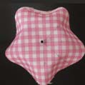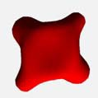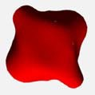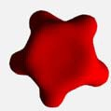

real effect

simulated

result

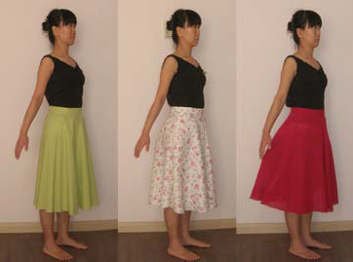Through the comparison of the intuitive visual experience and comprehensive evaluation index Ș, the results of the 3D textile simulation system were similar with the actual fabric drape, and the output of the prediction network was satisfactory. On this basis, the system also simulated the four-piece bias skirt made of three different fabrics. As shown in Fig 2, the implementation process from textile to garment could refer to the literature[10].

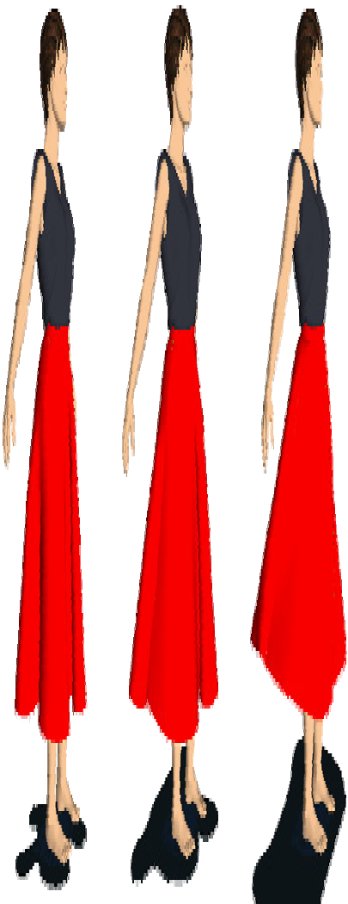

Fig.2.(a)three different fabrics made of four-piece bias skirt ;(b) corresponding simulation results (unused texture)

In the process of the system realization, we got the following conclusions:

1. Preferable input parameters of the prediction network has significance for network accuracy. If we use all the parameters of KES as the input data simply, the result is the high dimensionality of the network input. Simultaneously, the linear relationship of some parameters will disable the system to conclude the nonlinear relationship between the target and each variable. Statistical method was used to select appropriate network parameters. The data dimension was reduced from 16 to 7,which had the important significance for system realization.
2. BP neural network can be used to establish the non-linear mapping from fabric mechanical properties to the control parameters of the 3D textile simulation system. Scientifically determining the network structure, choosing the better transfer function and training function, normalizing the input data were the key factors of the implementation of system. The experiments showed that the 7-15-6 structure of BP network was more reasonable, and better stability and accuracy were gotten.
3. When we used the trained network to predict the textile simulation parameters, error sometimes was larger. This phenomenon represented the weak generalization ability of this nature network. Improvements can be made to solve the problem: Increase the number of samples,and pay attention to the reasonableness of its distribution. Make multiple measurements to ensure the accuracy of the input values of the samples. Improve the accuracy of network learning.
4. **Conclusion**

Garment design is an art, which faultlessly combines fabrics and body. The system hopes to establish a link between traditional structural mechanics analysis and computer simulation model. The simulated textiles with fabric material information can improve the realism of virtual clothing. Experiments show that the parameters come from KES can be used for simulating distinct type of textile, and the virtual clothing based on this method is more specific and will be propitious to improve the reality of the whole simulation system.

# Acknowledgements

This work has been sponsored by the Funding Project for Academic Human Resources Development in Institutions of Higher Learning Under the Jurisdiction of Beijing Municipality(PHR201008277). Beijing Key Lab of Digital Media & Human-Computer Interaction project(KF2012-13).

# References

1. Weil J. The synthesis of cloth objects[J]. ACM SIGGRAPH Computer Graphics,1986,20(4):49-54
2. Feynman C R. Modeling the appearance of cloth[D]. Boston: Massachusetts Institute of Technology, 1987
3. Liu Yongjin, Zhang Dongliang, Yuen M F M. A survey on CAD methods in 3D garment design[J].Computers in Industry,2010,61(6):576-593
4. Meng Yuwei, Mok.P.Y , Jin Xiaogang. Interactive Virtual Try-on Clothing Design Systems[J]. Journal Computer-Aided Design, 2010,42(4):310-321
5. Breen D E, House D H, Wozny M J. Predicting the drape of woven cloth using interacting particles[C]// Computer Graphics Proceedings, Annual Conference Series, ACM SIGGRAPH. Orlando:ACM Press,1994:365-372
6. Zhong Yueqi. Visulazition of fabric deformation[D].Shanghai: Donghua University,2000
7. Zuo Tonglin. Study on drape performance of fabrics and establishing of evaluation system.Shanghai:

Donghua University,2004

1. Lippmann R P. An introduction to computing with neural nets[J]. ACM SIGARCH Computer Architecture News,1988,16(1):7-25
2. VČra Kůrková.Kolmogorov's theorem and multilayer neural networks[J].Neural Networks,1992,5(3):501- 506
3. Jiang Yan, Wang Rui. Designing and realizing of the virtual sewing system[J]. Journal of Beijing Institute of Clothing Technology:Natural Science Edition,2010, 30(1):1-7

Contact of Corresponding Author

Yan Jiang, jsjjy@bift.edu.cn,13520428041